**IOT BASED SMART CROP PROTECTION SYSTEM FOR AGRICALTURE**

Team id:PNT2022TMID00315

SUBMITTED BY

Manoj kumar G 312319106097

Kishore kumar H 312319106083

Kowsigan N.P 312319106085

Mahizh V.S 312319106095

**In partial fulfilment for the award of the degree of**

**BACHELOR OF ENGINEERING**

**in**

**ELECTRONICS AND COMMUNICATION ENGINEERING**

**St.Joesph’s college of Engineering**

**An Autonomous Institution**

**CHAPTER-1**

**INTRODUCTION**

**1.1 PROJECT OVERVIEW**

Crops in farms are many times ravaged by local animals like buffaloes, cows, goats, birds etc. this leads to huge losses for the farmers. It is not possible for farmers to barricade entire fields or stay on field 24 hours and guard it.so here we propose automatic crop protection system from animals. This is a microcontroller based system using PIC family microcontroller. The microcontroller now sound an alarm to woo the animal away from the field as well as sends SMS to the farmer so that he may about the issue and come to the spot in case the animal don’t turn away by the alarm. This ensures complete safety of crop from animals thus protecting farmers loss.

**1.2 PURPOSE**

Our main purpose of the project is to develop intruder alert to the farm, to avoid losses due to animal and fire. These intruder alert protect the crop that damaging that indirectly increase yield of the crop. The develop system will not harmful and injurious to animal as well as human beings. Theme of project is to design a intelligent security system for farm protecting by using embedded system.

**CHAPTER-2**

**LITERATURE SURVEY:**

**2.1 EXISTING PROBLEM**

The existing system mainly provide the surveillance functionality. Also these system don’t provide protection from wild animals, especially in such an application area. They also need to take actions based on the type of animal that tries to enter the area, as different methods are adopted to prevent different animals from entering restricted areas. The other commonly used method by farmer in order to prevent the crop vandalization by animals include building physical barriers, use of electric fences andmanual surveillance and various such exhaustive and dangerous method.

**2.2 REFERENCES**

1. N.Penchalaiah, D.Pavithra, B.Bhargavi, D.P.Madhurai, K.EliyasShaik,S.Md.sohaib.Assitant Professor, Department of CSE,AITS, Rajampet,India UG Student, Department of CSE,AITS,Rajampet, India
2. Mohit Korche,Sarthak Tokse, ShubhamShirbhate, Vaibhav Thakre,S. P. Jolhe(HOD). Students , Final Year,Dept.of Electrical engineering,Government
3. Mr.Pranav shitap, Mr.Jayesh redij, Mr.Shikhar Singh, Mr.Durvesh Zagade, Dr. Sharada Chougule. Department of ELECTRONICS AND TELECOMMUNICATION ENGINEERING, Finolex Academy of Management and technology, ratangiri, India.
4. Mr.P.Venkateswara Rao, Mr.Ch Shiva Krishna ,MR M Samba Siva ReddyLBRCE,LBRCE,LBRCE.

**2.3 PROBLEM STATEMENT DEFINITION**

This project describes the method of tracking the crops and protecting the crops from the inserts and animals then it maintains the soil moisture, temperature etc.The traditional agriculture and allied sector cannot meet the requirements of modern Agriculture which requires high-yield, high quality and efficient output.Thus, it is very Important to turn towards modernization of existing methods and using the information Technology and data over a certain period to predict the best possible productivity and crop Suitable on the very particular land.The adoptions of access to high-speed internet, mobile devices, and reliable, low-cost Satellites (for imagery and positioning) are few key technologies characterizing the precision Agriculture trend.Precision agriculture is one of the most famous applications of IoT in the agricultural sector And numerous organizations are leveraging this technique around the world.IoT has been making deep inroads into sectors such as manufacturing, health-care and Automotive. When it comes to food production, transport and storage, it offers a breadth of Options that can improve India’s per capita food availability. Sensors that offer information On soil nutrient status, pest infestation, moisture conditions etc. which can be used to improve Crop yields over time.In Vidarbha region, Main Cash Crops such as Pigeon Pea, GreenGram, Black Gram, Jowar, Cotton, Soybean etc. present and are Badly affected by wild animals like Deer, Rohi (Neel Gai), wild Pigs,Peacock etc. In few districts in Vidarbha crop loss is more than 35%. Main Wild animals attacking crops in region are Akola, BuldhanaWashim etc.

In spite of economic development agriculture is the backbone of the economy. Crops in forms are many times ravaged by local animals like buffaloes, cows, goats, birds and fire etc. this leads to huge loss for the farmers.it is not possible for farmers to blockade to entire fields or stay 24 hours and guard it. Agriculture meetsfood requirements of the people and produces several raw materialsfor industries. But because of animal interference and fire in agricultural lands, there will be huge loss of crops.Crops will be totally getting destroyed

**CHAPTER-3**

**IDEATION AND PROPOSED SOLUTION:**

**3.1 EMPATHY MAP CANVAS**

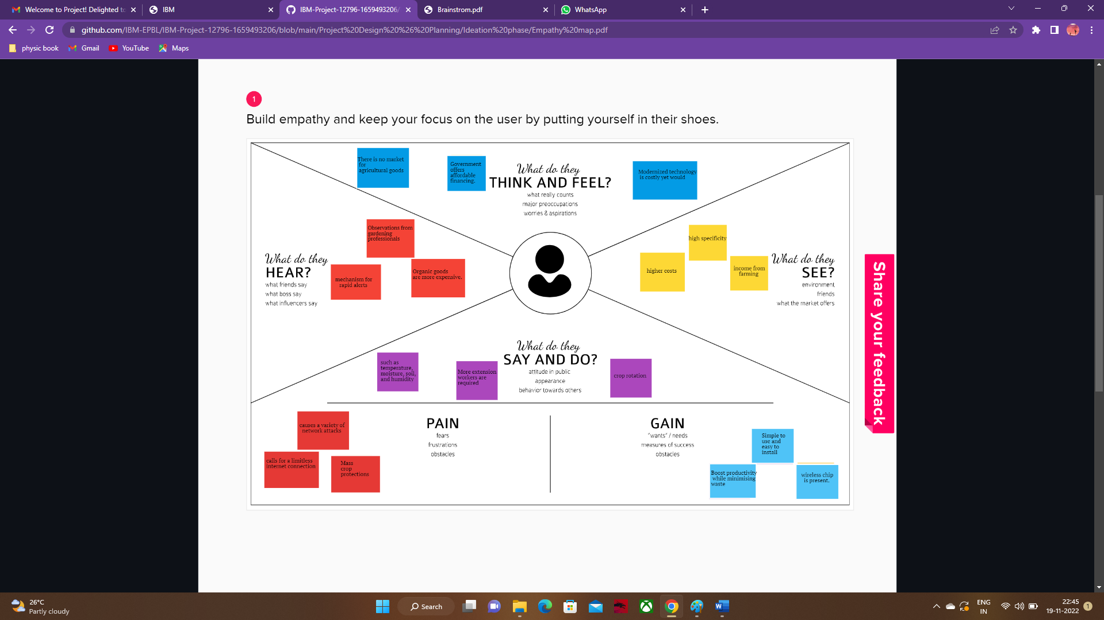

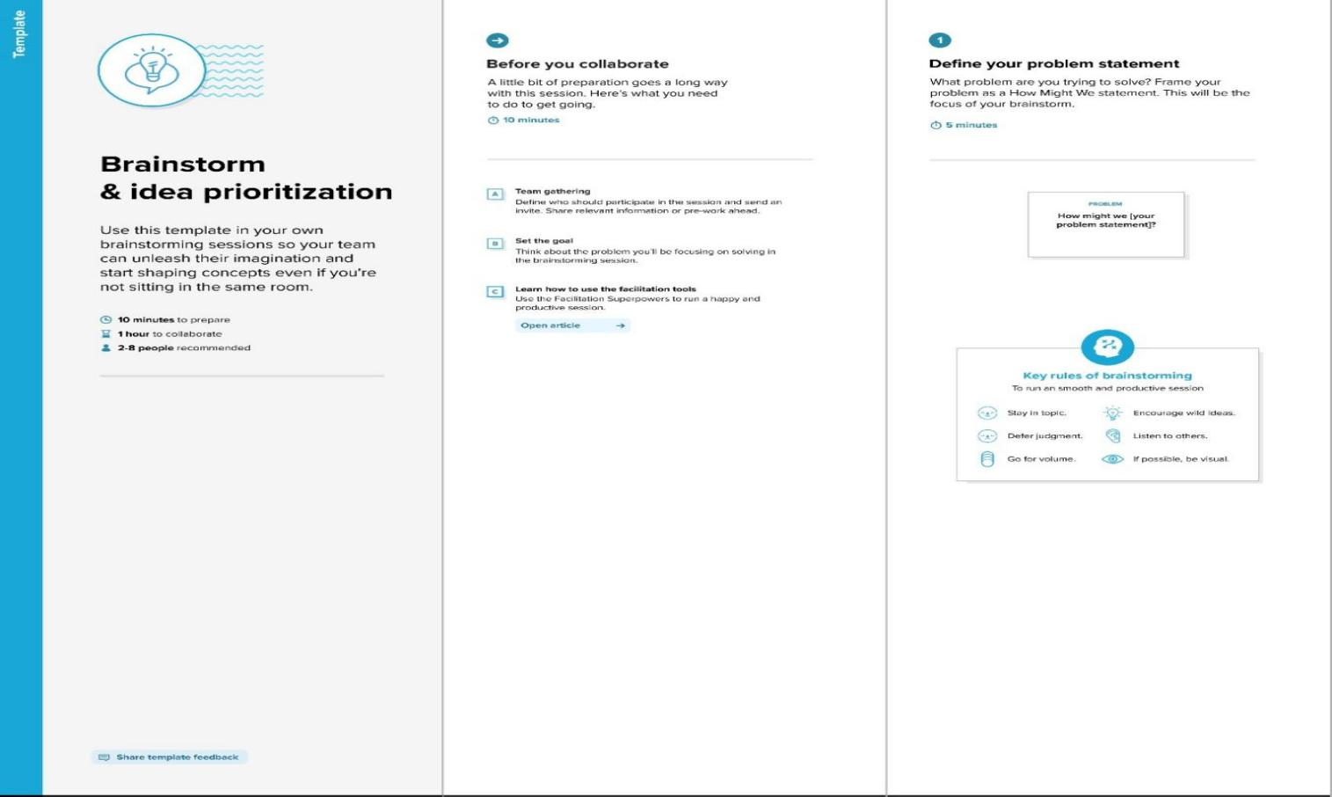**3.2 IDEATION AND BRAINSTORMING**

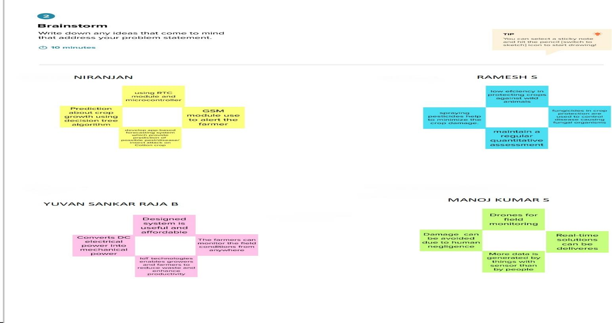

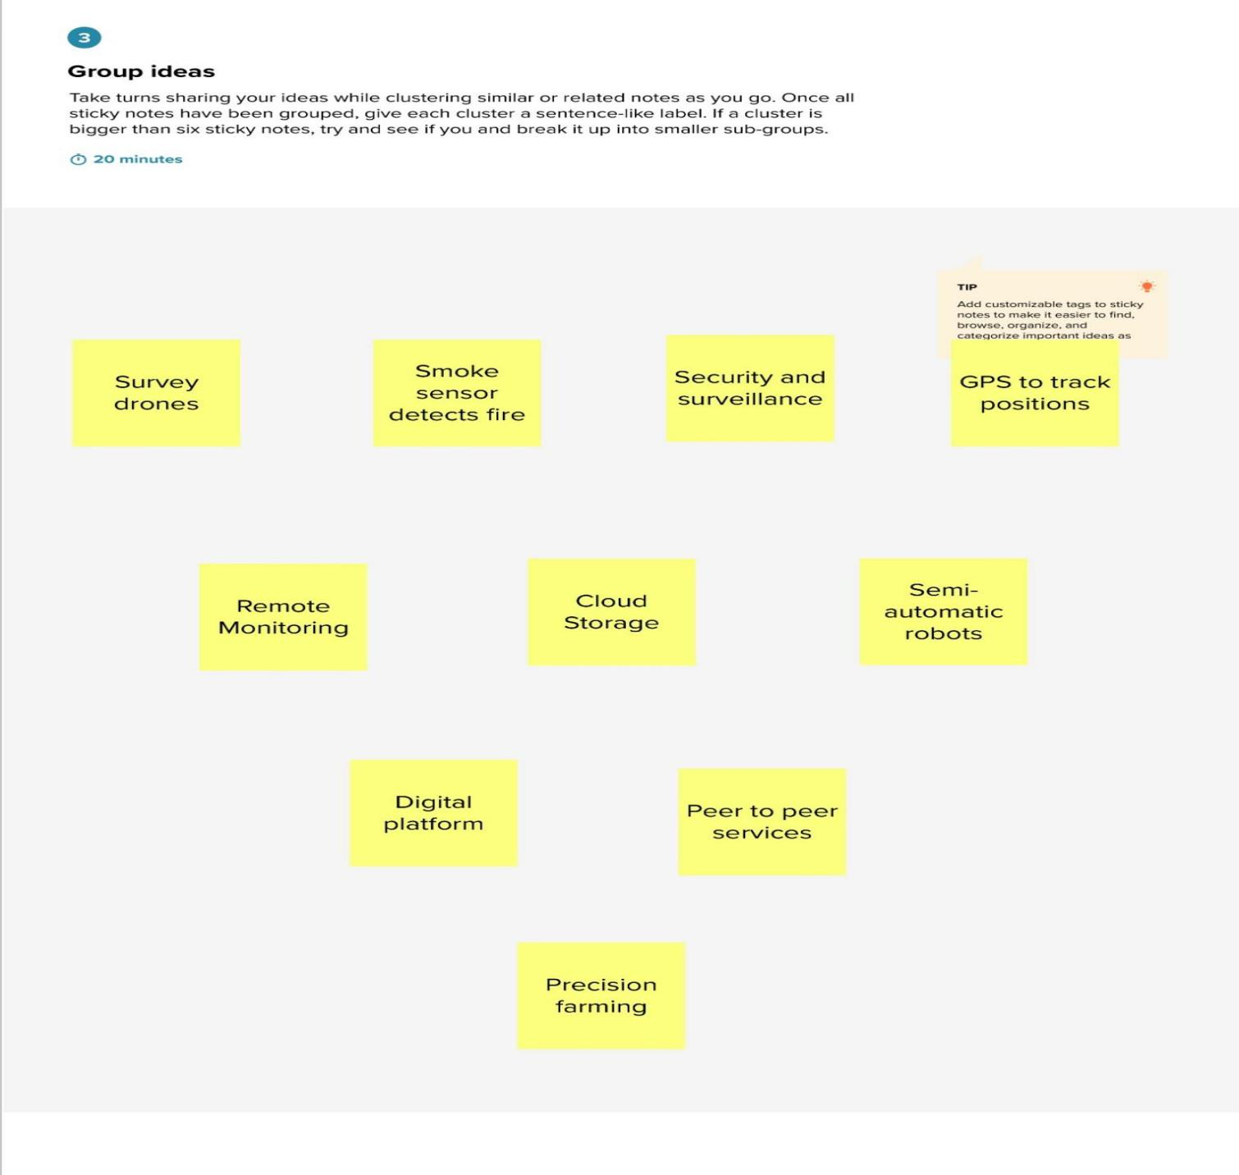

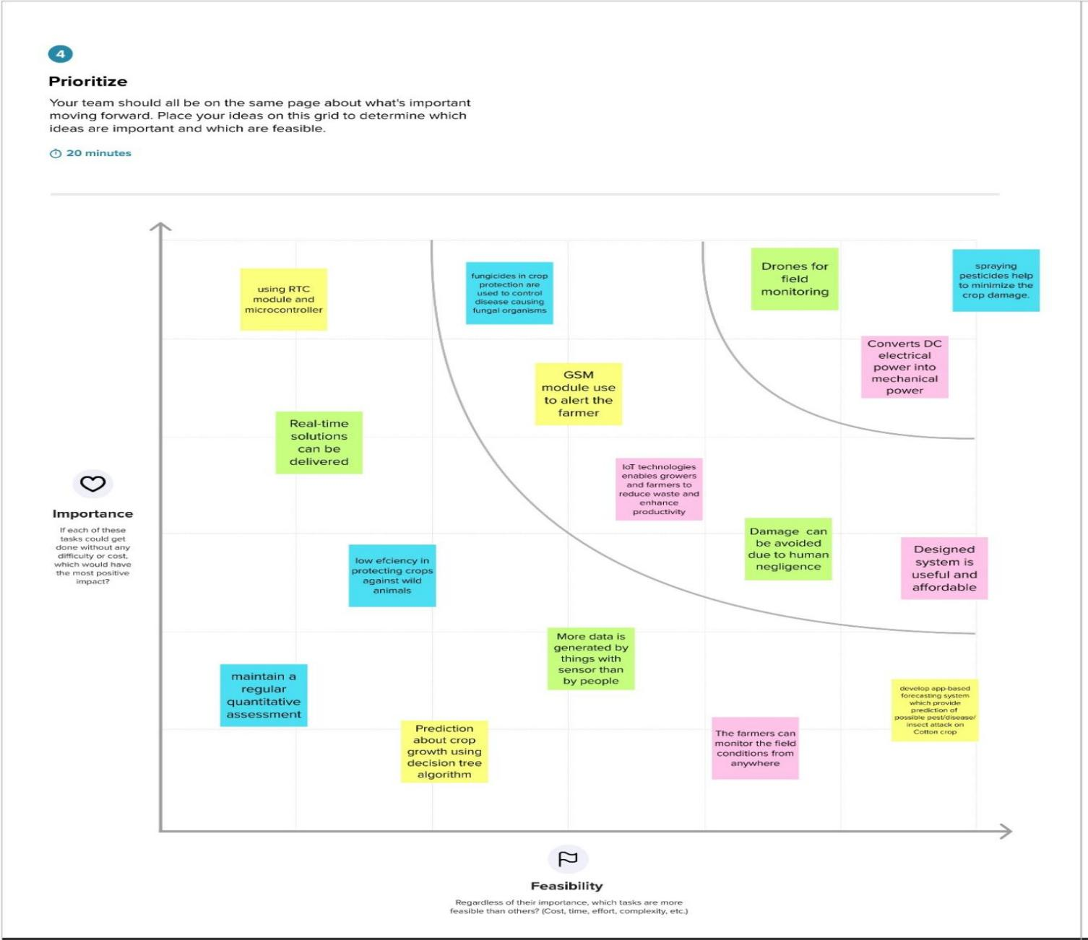

**3.3 PROPOSED SOLUTION**

|  |  |  |
| --- | --- | --- |
| **S.N**  **o.** | **Parameter** | **Description** |
| 1. | ProblemStatement (Problemtobe solved) | Develop an efficient system & an application that can monitor and alert the users(farmers) |
| 2. | Idea/Solution description | * This product helps the field in monitoring the animals other disturbance * In several areas, the temperature sensors will be integrated to monitor the temperature & humidity * If in any area feel dry or wet is detected by admins, will be notified along with the location in the web application |
| 3. | Novelty/Uniqueness | * Fastest alerts to the farmers * The increasing demand for quality food ➢User friendly |
| 4. | Social Impact/Customer Satisfaction | * Easy installation and provide efficient results * Can work with irrespective of fear |
| 5. | Business Model(Revenue Model) | * As the product usage can be understood by everyone, it is easy for them to use it properly for their safest organization * The product is advertised all over the platforms. Since it is economical, even helps small scale farming land from disasters. |
| 6. | Scalability of the Solution | ➢Even when the interruption is more, the product sense the accurate location and alerts the farmers effectively |

**3.4 PROBLEM SOLUTION FIT**

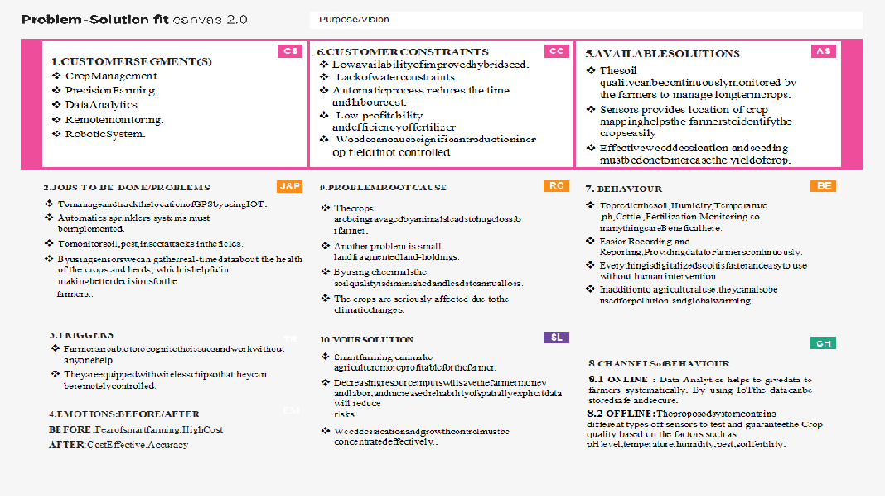

**CHAPTER-4**

**REQUIREMENT ANALYSIS**

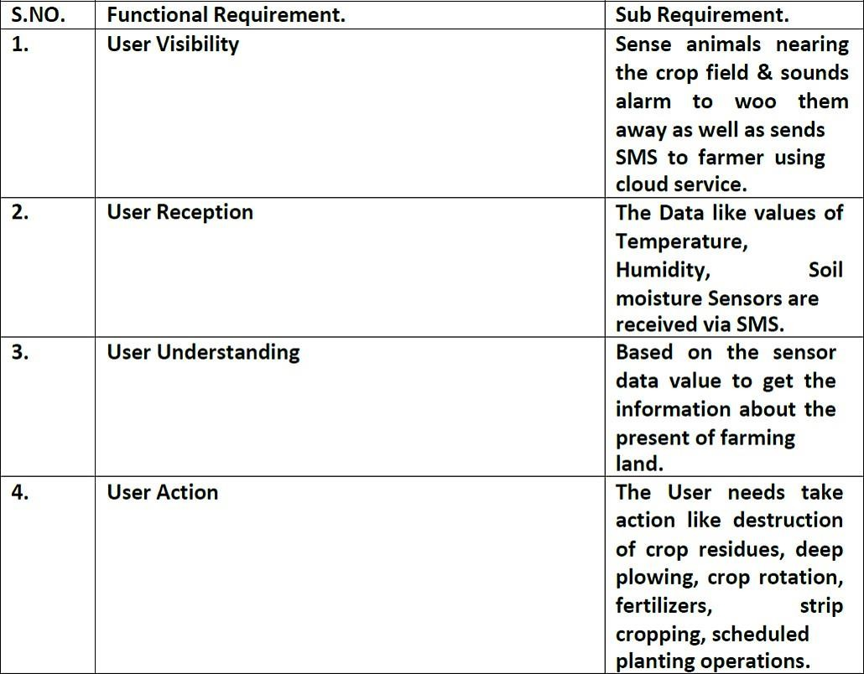**4.1 FUNCTIONAL REQUIREMENT**

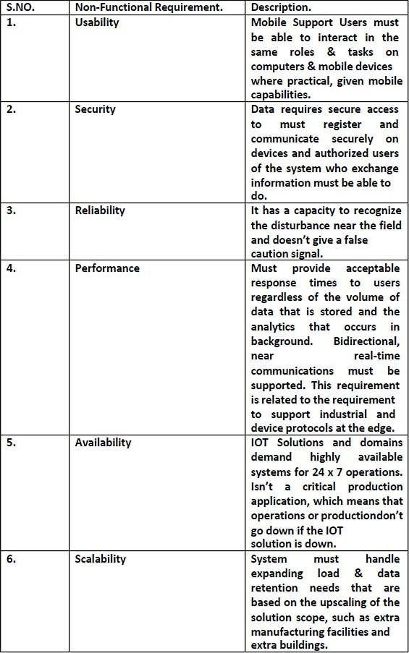**4.2 NON-FUNCTIONAL REQUIREMENT**

**CHAPTER-5**

**PROJECT DESIGN**

**5.1 DATA FLOW DIAGRAM**

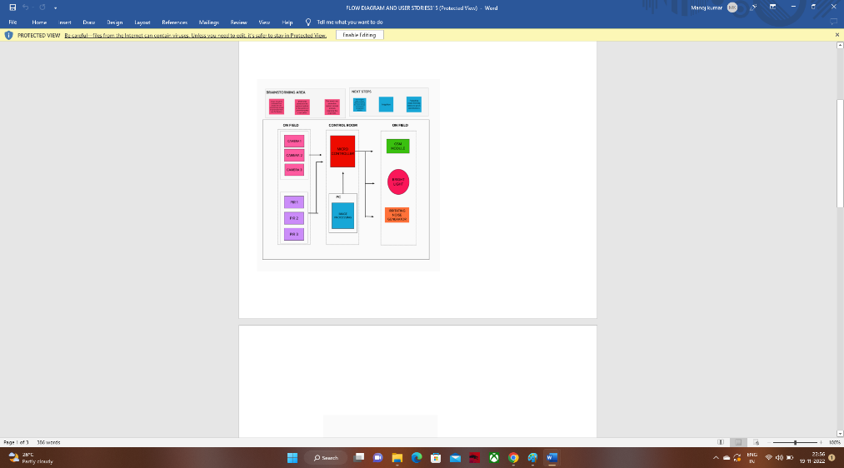

**5.2 SOLUTION AND TECHNICAL ARCHITECTURE**

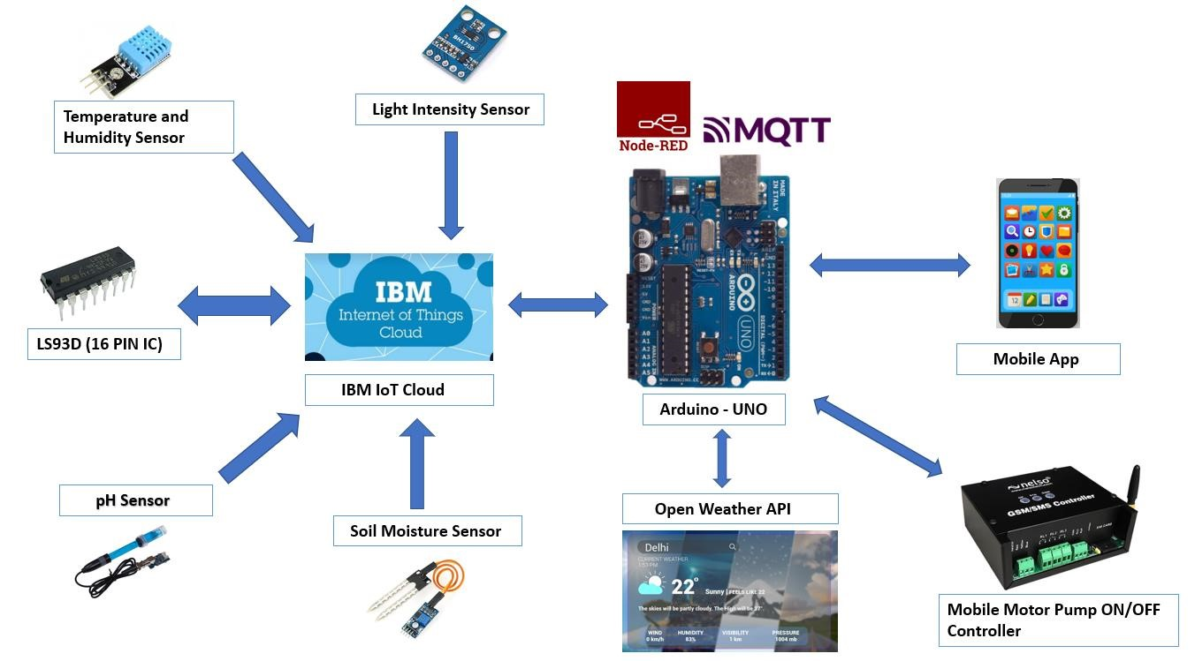

**5.3USER STORIES**

|  |  |  |  |  |  |  |
| --- | --- | --- | --- | --- | --- | --- |
| User Type | Functional  Requirement  (Epic) | User Story Number | User Story I Task | Acceptance criteria | Priority | Release |
|  |  | USN-4 | As a user, I can register for the application through Gmail | I can increase or decrease weather | Medium | Sprint-I |
|  |  | USN-5 | As a user, I can log into the application by entering email & password | I can access my weather status ahead in my field | High | Sprint-I |
|  | Dashboard | USN-6 | As a user, I can log into the open weather map by entering email & password | I can access the application through my Gmail login |  | Spint-2 |
| Customer (Web user) | Interface | USN-7 | As a user the interface should be simple and easily accessible | I can access the interface easily | Hligh | Spint-l |
| Customer Care Executive | Data generation | USN-8 | As a user open weather application to access the data regarding the weather changes | I can access the data regarding the weather through the application |  | Spint-l |
| Administrator | Problem Solving/  Fault clearance | USN-9 | As an official who is in charge for the proper fumnctioning of the sign boards have to maintain it through periodic monitoring. | Officials can monitor the sign boards for proper functioning | Medium | Spint-2 |

**CHAPTER-6**

**PROJECT PLANNING AND SCHEDULING:**

**6.1 SPRINT PLANNING AND ESTIMATION**

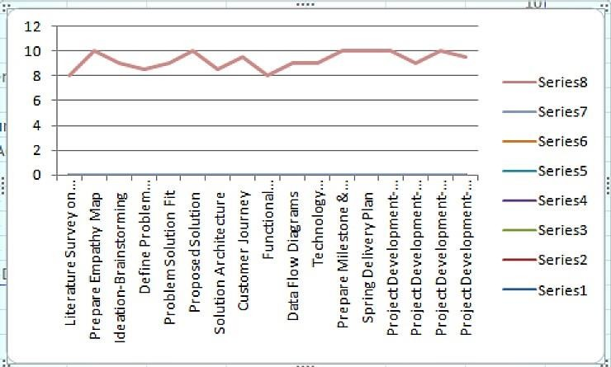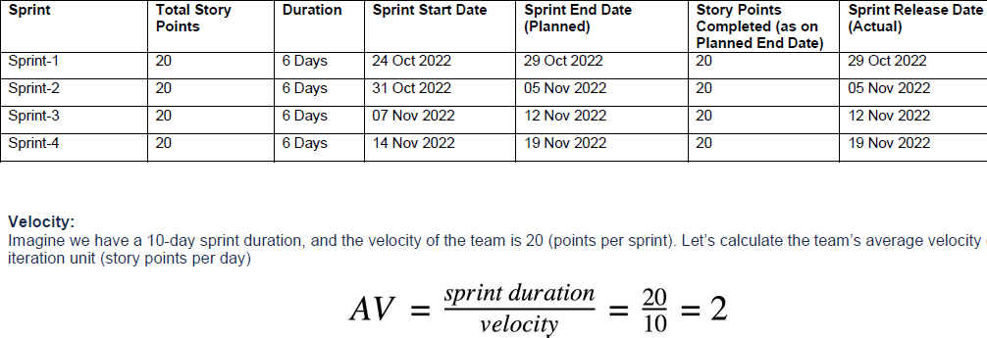

**6.2 SPRINT DELIVERY**

|  |  |  |  |  |  |  |
| --- | --- | --- | --- | --- | --- | --- |
| **Sprint** | **FunctionalRequirement(Epic)** | **UserStoryNumber** | **UserStory/Task** | **StoryPoints** | **Priority** | **TeamMembers** |
| Sprint-1 |  | US-1 | Create the IBMCloud serviceswhich are beingused in thisproject. | 6 | High | Manoj kumar G  Kishore kumar H  Kowsigan N.P  Mahizh V.S |
| Sprint-1 |  | US-2 | Configure theIBM Cloudservices whicharebeingusedincompleting thisproject. | 4 | Medium | Manoj kumar G  Kishore kumar H  Kowsigan N.P  Mahizh V.S |
| Sprint-2 |  | US-3 | IBMWatsonIoTplatform acts asthe mediator toconnect the webapplication toIoTdevices,so  createtheIBM | 5 | Medium | Manoj kumar G  Kishore kumar H  Kowsigan N.P  Mahizh V.S |

|  |  |  |  |  |  |  |
| --- | --- | --- | --- | --- | --- | --- |
| **Sprint** | **FunctionalRequirement(Epic)** | **UserStoryNumber** | **UserStory/Task** | **StoryPoints** | **Priority** | **TeamMembers** |
|  |  |  |  |  |  |  |
| Sprint-2 |  | US-4 | In order toconnect the IoTdevice to theIBM cloud,createadeviceinthe IBM WatsonIoT platform andget the devicecredentials. | 5 | High | Manoj kumar G  Kishore kumar H  Kowsigan N.P  Mahizh V.S |
| Sprint-3 |  | US-1 | Configure theconnectionsecurity andcreateAPIkeysthat are used inthe Node-REDservice foraccessing theIBMIoT  Platform. | 10 | High | Manoj kumar G  Kishore kumar H  Kowsigan N.P  Mahizh V.S |
| Sprint-3 |  | US-2 | CreateaNode-REDservice. | 10 | High | Manoj kumar G  Kishore kumar H  Kowsigan N.P  Mahizh V.S |
| Sprint-3 |  | US-1 | Developa | 7 | High | Kowsigan N.P |

|  |  |  |  |  |  |  |
| --- | --- | --- | --- | --- | --- | --- |
| **Sprint** | **FunctionalRequirement(Epic)** | **UserStoryNumber** | **UserStory/Task** | **StoryPoints** | **Priority** | **TeamMembers** |
| Sprint -2 |  | US-2 | python script topublish randomsensordatasuchas temperature,moisture, soiland humidity tothe IBM IoTplatform |  |  | Manoj kumar G  Kishore kumar H  Kowsigan N.P  Mahizh V.S |
| Sprint-3 |  | US-2 | After developingpython code,commands arereceived justprint thestatements whichrepresent thecontrol of thedevices. | 5 | Medium | Manoj kumar G  Kishore kumar H  Kowsigan N.P  Mahizh V.S |
| Sprint-4 |  | US-3 | Publish Data toTheIBMCloud | 8 | High | Manoj kumar G  Kishore kumar H  Kowsigan N.P  Mahizh V.S |
| Sprint-4 |  | US-1 | Create Web UIinNode-Red | 10 | High | Manoj kumar G  Kishore kumar H  Kowsigan N.P  Mahizh V.S |

|  |  |  |  |  |  |  |
| --- | --- | --- | --- | --- | --- | --- |
| **Sprint** | **FunctionalRequirement(Epic)** | **UserStoryNumber** | **UserStory/Task** | **StoryPoints** | **Priority** | **TeamMembers** |
| Sprint-4 |  | US-2 | Configure theNode-RED flowto receive datafrom the IBMIoT platform andalsouseCloudant DBnodestostorethe receivedsensordatainthecloudantDB | 10 | High | Manoj kumar G  Kishore kumar H  Kowsigan N.P  Mahizh V.S |

**CHAPTER-7**

**CODING AND SOLUTION**

**7.1 FEATURE 1**

import time import sys

import ibmiotf.application # to install pip install ibmiotf import ibmiotf.device

#Provide your IBM Watson Device Credentials organization = "hrodmj" #replace the ORG ID deviceType = "NODEMCU1"#replace the Device type wi deviceId = "12345"#replace Device ID

authMethod = "token"

authToken = "kp1234" #Replace the authtoken

def myCommandCallback(cmd): # function for Callback print("Command received: %s" % cmd.data)

if cmd.data['command']=='motoron': print("Motor On IS RECEIVED")

elif cmd.data['command']=='motoroff': print("Motor Off IS RECEIVED")

if cmd.command == "setInterval":

if 'interval' not in cmd.data:

print("Error - command is missing required information: 'interval'") else:

interval = cmd.data['interval'] elif cmd.command == "print":

if 'message' not in cmd.data:

print("Error - command is missing required information: 'message'") else:

output=cmd.data['message'] print(output)

deviceOptions = {"org": organization, "type": deviceType, "id": deviceId, "auth-method": authMethod, "auth-token": authToken}

deviceCli = ibmiotf.device.Client(deviceOptions) #..............................................

except Exception as e:

print("Caught exception connecting device: %s" % str(e)) sys.exit()

# Connect and send a datapoint "hello" with value "world" into the cloud as an event of type "greeting" 10 times

deviceCli.connect() while True:

deviceCli.commandCallback = myCommandCallback # Disconnect the device and application from the cloud deviceCli.disconnect()

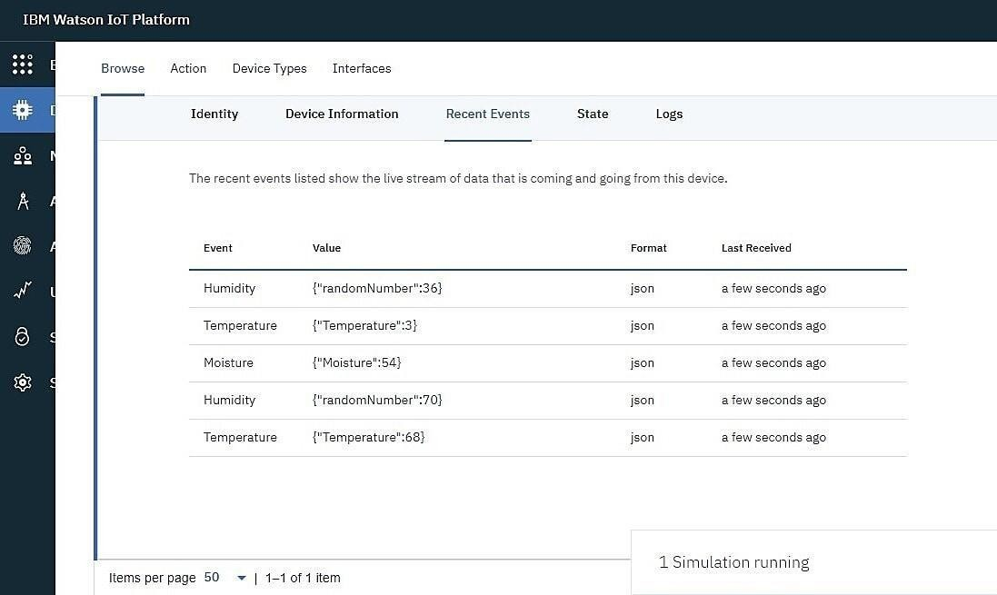

**7.2 FEATURE 2**

1. Good sensitivity to Combustible gas in wide range .
2. High sensitivity to LPG, Propane and Hydrogen .
3. Long life and low cost.
4. Simple drive circuit.

**CHAPTER-8**

**TESTING**

## 8.1 TEST CASES

|  |  |  |  |
| --- | --- | --- | --- |
| sno | Parameter | Values | Screenshot |
|  |  |  |  |
| 1 | Model summary | - |  |
| 2 | Accuracy | Training  accuracy- 95%  Validation accuracy-  72% |  |
| 3 | Confidence score | Class  detected- 80%  Confidence score-80% |  |

## 8.2 USER ACCEPTANCE TESTING

## 

## 

## 

## CHAPTER-09

## RESULT

### The problem of crop vandalization by wild animals and fire has become a major social problem in current time.

It requires urgent attention as no effective solution exists till date for this problem. Thus this project carries a great social relevance as it aims to address this problem. This project will help farmers in protecting their orchards and fields and save them from significant financial losses and will save them from the unproductive efforts that they endure for the protection their fields. This will also help them in achieving better crop yields thus leading to their economic wellbeing.

## CHAPTER-10

## ADVANTAGES AND DISADVANTAGES

#### Advantage:

Controllable food supply. you might have droughts or floods, but if you are growing the crops and breeding them to be hardier, you have a better chance of not straving. It allows farmers to maximize yields using minimum resources such as water fertilizers.

**Disadvantage:**

The main disadvantage is the time it can take to process the information.in order to keep feeding people as the population grows you have to radically change then environment of the planet.

**CHAPTER-11**

**CONCLUSION**

A IoT Web Application is built for smart agricultural system using Watson IoT platform, Watson stimulator, IBM cloud and Node-RED

## CHAPTER-12

## FUTURE SCOPE

In the future, there will be very large scope, this project can be made based on Image processing in which wild animaland fire can be detected by cameras and if it comes towards form then system will be directly activated through wireless networks. Wild animals can also be detected by using wireless networks such as laser wireless sensors and by sensing this laser or sensor’s security system will be activated.

## CHAPTER-13

## APPENDIX

**SOURCE CODE**

# MOTOR.PY

import time import sys

import ibmiotf.application # to install pip install ibmiotf import ibmiotf.device

# Provide your IBM Watson Device Credentials organization = "8gyz7t" # replace the ORG ID

deviceType = "weather_monitor" # replace the Device type deviceId = "b827ebd607b5" # replace Device ID authMethod = "token"

authToken = "LWVpQPaVQ166HWN48f" # Replace the authtoken

def myCommandCallback(cmd): # function for Callback if cmd.data['command'] == 'motoron':

print("MOTOR ON IS RECEIVED")

elif cmd.data['command'] == 'motoroff': print("MOTOR OFF IS RECEIVED")

if cmd.command == "setInterval": if 'interval' not in cmd.data:

print("Error - command is missing required information: 'interval'")

else:

interval = cmd.data['interval'] elif cmd.command == "print":

if 'message' not in cmd.data:

print("Error - command is missing required information: 'message'")

else:

output = cmd.data['message'] print(output)

try:

deviceOptions = {"org": organization, "type": deviceType, "id": deviceId, "auth- method": authMethod,

"auth-token": authToken}

deviceCli = ibmiotf.device.Client(deviceOptions) # ..............................................

except Exception as e:

print("Caught exception connecting device: %s" % str(e)) sys.exit()

# Connect and send a datapoint "hello" with value "world" into the cloud as an event of type "greeting" 10 times

deviceCli.connect()

while True:

deviceCli.commandCallback = myCommandCallback

# Disconnect the device and application from the cloud deviceCli.disconnect()

# SENSOR.PY

import time import sys

import ibmiotf.application import ibmiotf.device import random

# Provide your IBM Watson Device Credentials organization = "8gyz7t" # replace the ORG ID

deviceType = "weather_monitor" # replace the Device type deviceId = "b827ebd607b5" # replace Device ID authMethod = "token"

authToken = "LWVpQPaVQ166HWN48f" # Replace the authtoken

def myCommandCallback(cmd):

print("Command received: %s" % cmd.data['command']) print(cmd)

try:

deviceOptions = {"org": organization, "type": deviceType, "id": deviceId,

"auth-method": authMethod, "auth-token": authToken} deviceCli = ibmiotf.device.Client(deviceOptions) #..............................................

except Exception as e:

print("Caught exception connecting device: %s" % str(e)) sys.exit()

# Connect and send a datapoint "hello" with value "world" into the cloud as an event of type "greeting" 10 times

deviceCli.connect()

while True:

temp=random.randint(0,100) pulse=random.randint(0,100) soil=random.randint(0,100)

data = { 'temp' : temp, 'pulse': pulse ,'soil':soil}

#print data

def myOnPublishCallback():

print ("Published Temperature = %s C" % temp, "Humidity = %s %%" % pulse,"Soil Moisture = %s %%" % soil,"to IBM Watson")

success = deviceCli.publishEvent("IoTSensor", "json", data, qos=0, on_publish=myOnPublishCallback)

if not success:

print("Not connected to IoTF") time.sleep(1)

deviceCli.commandCallback = myCommandCallback

# Disconnect the device and application from the cloud deviceCli.disconnect()

# Node-RED FLOW :

[

{ "id":"625574ead9839b34",

"type":"ibmiotout", "z":"630c8601c5ac3295",

"authentication":"apiKey", "apiKey":"ef745d48e395ccc0", "outputType":"cmd", "deviceId":"b827ebd607b5", "deviceType":"weather_monitor", "eventCommandType":"data", "format":"json",

"data":"data", "qos":0, "name":"IBM IoT", "service":"registered",

"x":680,

"y":220,

"wires":[]

},

{

"id":"4cff18c3274cccc4", "type":"ui_button", "z":"630c8601c5ac3295",

"name":"", "group":"716e956.00eed6c", "order":2,

"width":"0",

"height":"0", "passthru":false, "label":"MotorON",

"tooltip":"",

"color":"",

"bgcolor":"",

"className":"",

"icon":"", "payload":"{\"command\":\"motoron\"}", "payloadType":"str",

"topic":"motoron",

"topicType":"str", "x":360,

"y":160, "wires":[["625574ead9839b34"]]},

{

"id":"659589baceb4e0b0", "type":"ui_button", "z":"630c8601c5ac3295",

"name":"", "group":"716e956.00eed6c", "order":3,

"width":"0",

"height":"0", "passthru":true, "label":"MotorOFF",

"tooltip":"",

"color":"",

"bgcolor":"",

"className":"",

"icon":"", "payload":"{\"command\":\"motoroff\"}", "payloadType":"str",

"topic":"motoroff",

"topicType":"str", "x":350,

"y":220, "wires":[["625574ead9839b34"]]},

{"id":"ef745d48e395ccc0", "type":"ibmiot", "name":"weather_monitor", "keepalive":"60",

"serverName":"", "cleansession":true, "appId":"",

"shared":false},

{"id":"716e956.00eed6c",

"type":"ui_group",

"name":"Form", "tab":"7e62365e.b7e6b8", "order":1,

"disp":true, "width":"6", "collapse":false},

{"id":"7e62365e.b7e6b8",

"type":"ui_tab",

"name":"contorl",

"icon":"dashboard", "order":1, "disabled":false, "hidden":false}

]

[

{

"id":"b42b5519fee73ee2", "type":"ibmiotin", "z":"03acb6ae05a0c712", "authentication":"apiKey", "apiKey":"ef745d48e395ccc0", "inputType":"evt", "logicalInterface":"", "ruleId":"", "deviceId":"b827ebd607b5", "applicationId":"",

"deviceType":"weather_monitor", "eventType":"+",

"commandType":"",

"format":"json",

"name":"IBMIoT", "service":"registered", "allDevices":"", "allApplications":"", "allDeviceTypes":"", "allLogicalInterfaces":"", "allEvents":true, "allCommands":"",

"allFormats":"", "qos":0,

"x":270,

"y":180,

"wires":[["50b13e02170d73fc","d7da6c2f5302ffaf","a949797028158f3f","a71f164bc3 78bcf1"]]

},

{ "id":"50b13e02170d73fc",

"type":"function", "z":"03acb6ae05a0c712", "name":"Soil Moisture",

"func":"msg.payload = msg.payload.soil;\nglobal.set('s',msg.payload);\nreturn msg;", "outputs":1,

"noerr":0, "initialize":"",

"finalize":"",

"libs":[], "x":490,

"y":120,

"wires":[["a949797028158f3f","ba98e701f55f04fe"]]

},

{

"id":"d7da6c2f5302ffaf", "type":"function", "z":"03acb6ae05a0c712", "name":"Humidity",

"func":"msg.payload = msg.payload.pulse;\nglobal.set('p',msg.payload)\nreturn msg;", "outputs":1,

"noerr":0, "initialize":"",

"finalize":"",

"libs":[], "x":480,

"y":260, "wires":[["a949797028158f3f","70a5b076eeb80b70"]]

},

{ "id":"a949797028158f3f",

"type":"debug", "z":"03acb6ae05a0c712", "name":"IBMo/p", "active":true, "tosidebar":true, "console":false, "tostatus":false, "complete":"payload", "targetType":"msg",

"statusVal":"", "statusType":"auto", "x":780,

"y":180,

"wires":[]

},

{

"id":"70a5b076eeb80b70", "type":"ui_gauge", "z":"03acb6ae05a0c712", "name":"", "group":"f4cb8513b95c98a4", "order":6,

"width":"0",

"height":"0",

"gtype":"gage",

"title":"Humidity",

"label":"Percentage(%)",

"format":"{{value}}", "min":0, "max":"100",

"colors":["#00b500","#e6e600","#ca3838"],

"seg1":"",

"seg2":"",

"className":"", "x":860,

"y":260,

"wires":[]

},

{

"id":"a71f164bc378bcf1", "type":"function", "z":"03acb6ae05a0c712", "name":"Temperature",

"func":"msg.payload=msg.payload.temp;\nglobal.set('t',msg.payload);\nreturn msg;", "outputs":1,

"noerr":0, "initialize":"",

"finalize":"",

"libs":[], "x":490,

"y":360,

"wires":[["8e8b63b110c5ec2d","a949797028158f3f"]]

},

{

"id":"8e8b63b110c5ec2d", "type":"ui_gauge", "z":"03acb6ae05a0c712", "name":"", "group":"f4cb8513b95c98a4", "order":11,

"width":"0",

"height":"0",

"gtype":"gage", "title":"Temperature", "label":"DegreeCelcius",

"format":"{{value}}", "min":0, "max":"100",

"colors":["#00b500","#e6e600","#ca3838"], "seg1":"",

"seg2":"",

"className":"", "x":790,

"y":360,

"wires":[]

},

{

"id":"ba98e701f55f04fe", "type":"ui_gauge", "z":"03acb6ae05a0c712", "name":"", "group":"f4cb8513b95c98a4", "order":1,

"width":"0",

"height":"0",

"gtype":"gage", "title":"Soil Moisture", "label":"Percentage(%)",

"format":"{{value}}", "min":0, "max":"100",

"colors":["#00b500","#e6e600","#ca3838"], "seg1":"",

"seg2":"",

"className":"", "x":790,

"y":120,

"wires":[]

},

{

"id":"a259673baf5f0f98", "type":"httpin", "z":"03acb6ae05a0c712", "name":"",

"url":"/sensor",

"method":"get", "upload":false, "swaggerDoc":"", "x":370,

"y":500,

"wires":[["18a8cdbf7943d27a"]]

},

{

"id":"18a8cdbf7943d27a", "type":"function", "z":"03acb6ae05a0c712", "name":"httpfunction",

"func":"msg.payload{\"pulse\":global.get('p'),\"temp\":global.get('t'),\"soil\":global.get( 's')};\nreturn msg;",

"outputs":1,

"noerr":0, "initialize":"",

"finalize":"",

"libs":[], "x":630,

"y":500, "wires":[["5c7996d53a445412"]]

},

{ "id":"5c7996d53a445412",

"type":"httpresponse", "z":"03acb6ae05a0c712", "name":"",

"statusCode":"",

"headers":{}, "x":870,

"y":500,

"wires":[]

},

{

"id":"ef745d48e395ccc0", "type":"ibmiot", "name":"weather_monitor", "keepalive":"60",

"serverName":"", "cleansession":true, "appId":"",

"shared":false},

{

"id":"f4cb8513b95c98a4", "type":"ui_group",

"name":"monitor", "tab":"1f4cb829.2fdee8", "order":2,

"disp":true, "width":"6", "collapse":false, "className":""

},

{

"id":"1f4cb829.2fdee8",

"type":"ui_tab",

"name":"Home",

"icon":"dashboard", "order":3, "disabled":false, "hidden":false }

### DEMO LINK:

**https://github.com/IBM-EPBL/IBM-Project-12796-1659493206/blob/main/Final%20deliverables/demo-video/demo-video(1).mp4**